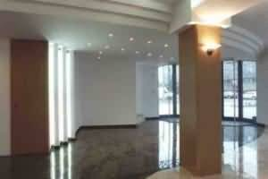 | 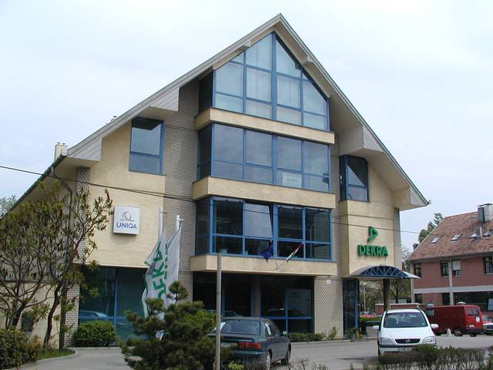 | 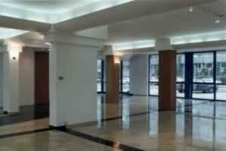

OBUDA BUSINESS CENTER TO LET
1200 m2 net space + 2800 m2 open area

The original and real functionality of the building is a medium sized COMPANY HEADQUARTERS which has products to show or sell on the exclusive ground and first floors, with proper lighting! The 2nd floor is the management and offices area. On the 3rd. floor the conference/lecture rooms, or studios can be found, with a catering kitchen. The building was originally constructed for our own purpose (www.johns.hu).

Several functionality can be suggested for the building: Medical Clinics and Pharmaceutical companies, Medicine companies, bank or insurance branch office, publishers, car dealers, textile, shoes and technical products.... Also excellent for open office concept companies like computer technology! Previously the complete building was leased by CAP GEMINI computer company with 60-100 employees for 3 years and DEKRA EXPERT and UNIQA Insurance companies for 8 years.

In front of the building the high tech Hungarian Television Studios and offices has been completed so the area is in a new and well kept surrounding. Our neighbours are HILTI INTERNATIONAL, REVAI PRINTING HOUSE, HUNGARIAN TV, GRIFF GENTLEMENS. HONDA DEALER. Companies nearby: Many car dealers and Grafisoft Park is also very near, with all kind of shopping centers EUROCENTER, LIDL,PENNY Market... Bus stops in front of the building

Please find detailed pdf documentation on the following links:

http://www.johns.hu/Letoltesek/OBC_English.pdf
http://www.johns.hu/Irodahaz/Irodahaz.html

You can find location in GOOGLE EARTH under:
Budapest, Obuda Business Center

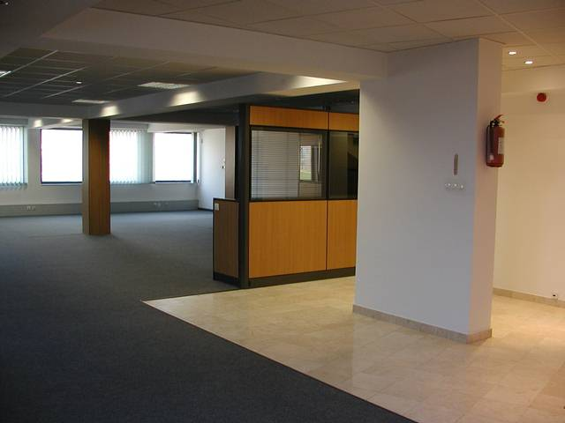 | 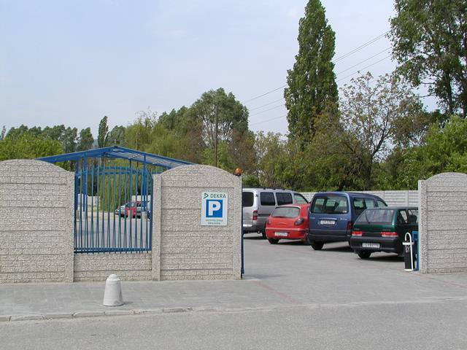 | 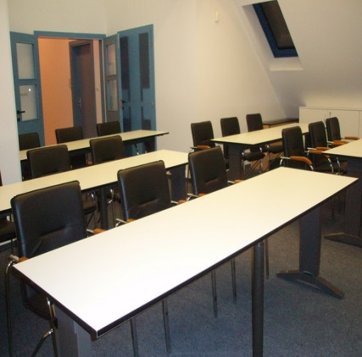

OBUDA BUSINESS CENTER TO LET

GROUND AND FIRST FLOOR WITH EXCLUSIVE OPEN OFFICES

Below you can see the photos of the ground floor (360sqm) and the first floor (360sqm) of the office-complex. The rooms are airconditioned and the flooring is marble covered with heating below (floor heating). Both floor has a sliding spot light system in addition to the normal hidden lighting. To the ground floor is directly connected a closed parking lot for cca. 120 cars which makes both floors ideal for commertial, demostration space, conferences or open office concept.
On both floors kichenette units are installed and phone and computer cabling are available with distribution racks. A lift is installed behind the reception area!

Fees for long term letting:
Rent fee: 8 EUR/sqm/month net, for a minimum of 1 year rent.
Closed but not covered parking lot: 20 EUR/car/month net
Overhead charges: electricity according to separate floor-meter, gas and water according to sqm distribution.

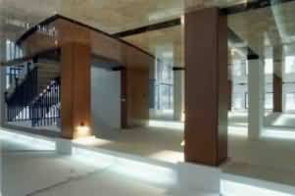

OBUDA BUSINESS CENTER
II. FLOOR
EXLUSIVE OFFICE SPACE TO LET

Below you can see the photos of the 2nd floor (310sqm) of the office-complex, still available for renting. All rooms on this floor are separately heated and airconditioned and are partially furnished by built-in storage cupboards. The floor is partially open office, with 2 separated management room and one service room for computers or accounting.
The floor has a separate kitchenette, toilets and 2 managerial toalets with doushe. A private lift arrives to this floor!
The floor has an installed phone and computer cabling system with a distribution cabinet in the service room!

Fees for long term letting:
Rent fee: 8 EUR/sqm/month net, for a minimum of 1 year
Closed but not covered parking lot: 20 EUR/car/month net
Overhead charges: electricity according to separate floor-meter, gas and water according to sqm distribution.

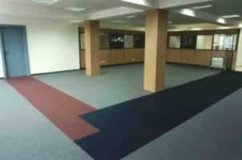 | 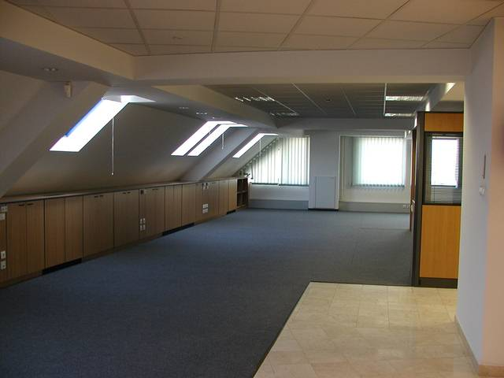 | 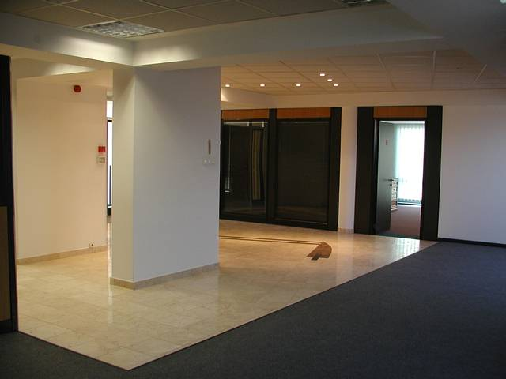
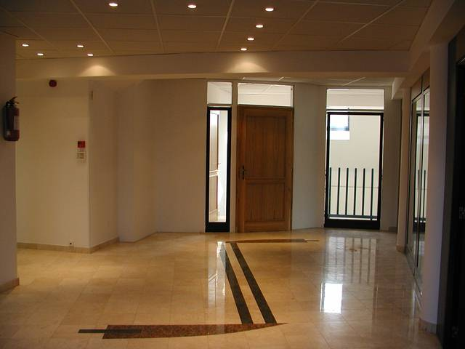 |  | 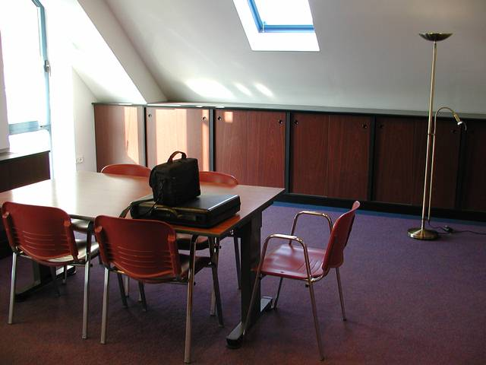
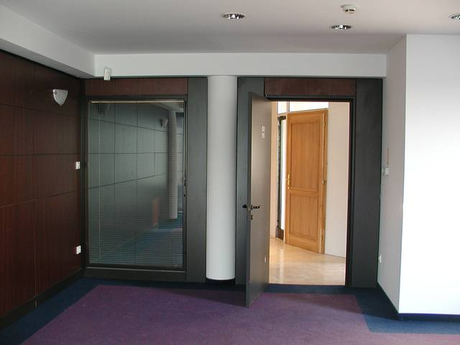 | 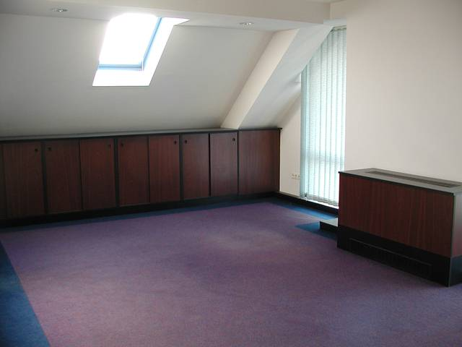 | 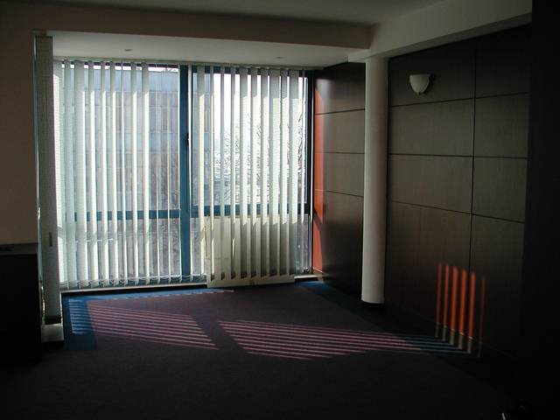

OBUDA BUSINESS CENTER III. FLOOR
CONFERENCE AND EDUCATION CENTER. STUDIOS

Below you can see the photos of the 3rd floor (app. 150 sqm) of the office-complex, still available to rent. We are offering 2 alternative: unfurnished or furnished as lecture/conference room
The rooms are airconditioned!

- alternativ, unfurnished, for long term letting, the fees are:
Rent fee: 8 EUR/sqm/month net, for a minimum of 1 year.
Overhead charges: electricity according to separate floor-meter, gas and water according to sqm distribution.
- alternativ:
furnished as lecture/conference room. 2 rooms are available each can corporate 15 person with tables or 30 person with only chairs.
Cost : 120 Euro net/room per occasion (max. 1 day).
The rooms have a common reception area with hangers for the cloths, service-kitchen and toalets. For the events we offer free parking for the visitors.

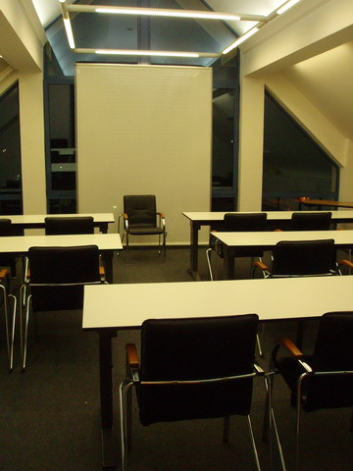 | 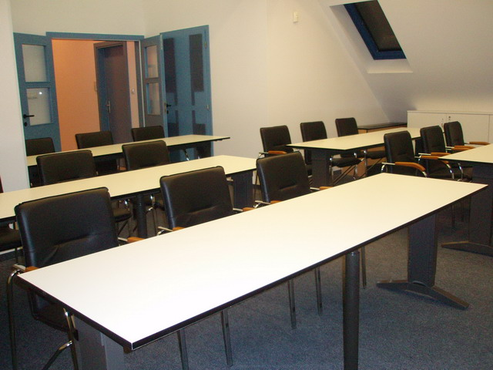 | 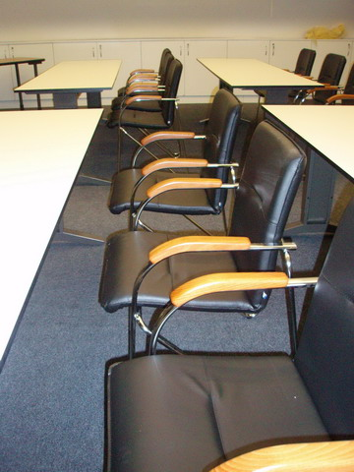
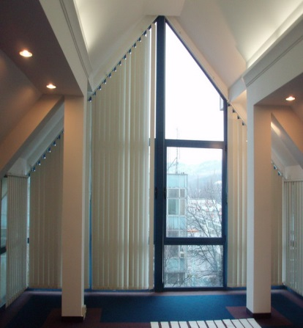 | 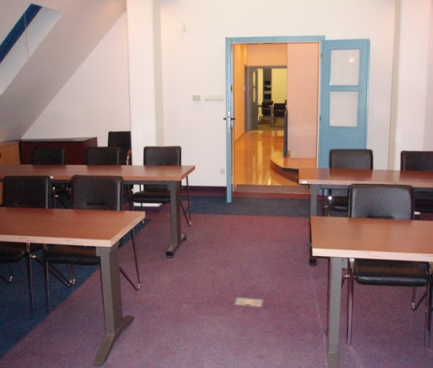 | 